**Expression of Interest**

**Emissions Reduction Alberta**

**Industrial Transformation Challenge**

1. **Proposal Information**

|  |  |
| --- | --- |
| Project Title: | Solar Heat for Industrial Process + Thermal Energy Storage |
| Lead Applicant Organization: | SolarSteam Inc. |
| Project Location(s): | Cynthia, Alberta |
| Project Start Date: | August 1, 2023 |
| Project Completion Date: | July 30, 2026 |
| Total Project Budget: | 6,000,000 |
| Total Project Eligible Cost: | 5,600,000 |
| Requested ERA Funding: | 2,500,000 |
| Applicant Contact Email: | apostol@solarsteam.ca |

1. **Innovation Opportunity**

[SolarSteam](https://solarsteam.ca/)’s core technology **(**[**VIDEO LINK**](https://www.youtube.com/watch?v=9yRn2qt0Lfk)**)** relies on time-tested and well proven methods utilizing a parabolic trough reflector (collector/concentrator) that focuses sunlight onto a central tube receiver to heat fluid within. However, parabolic trough collector technology for extreme climates is not currently available in the marketplace. Using current technology has proved not to be feasible due to inability for conventional systems to withstand snow, hail and most importantly wind. The exposure to harsh weather conditions results in higher CAPEX costs for denser structural materials and heavily reinforced foundations of the system as well as very high maintenance costs (collector cleaning and repairs) without gaining any efficiencies. A non-enclosed, Concentrated Solar Power (CSP) system was previously developed in Medicine Hat, which is a system considerably different from SolarSteam’s technology which offers major improvements in CAPEX, integration, operations, maintenance and GHG offset.

**The key innovations** that allow us to offer improvement in functionality and lower cost compared to traditional solar thermal suppliers are our double sloped enclosure that is uniquely shaped and covered to manage extreme weather, and simple integration into existing processes. The envelope material is selected to maximize solar radiation into the building whilst providing sufficient protection from wind, rain, snow, and hail loading. This allows for the use of ultra-light light collectors which are easier and cheaper to manufacture locally in Alberta. This transformative design is specifically developed for ease of manufacturing, shipping, and assembly to enable deployment and scaling in conditions for which current applications are not possible or feasible. The SolarSteam system is designed to be modular to reduce manufacturing, assembly, and maintenance costs. Each of the components including the foundation structures, arches, membranes, thermal pipes, reflector and collector assembly, support bearing assembly, and control system can be manufactured with consistent dimensions as a single thermal module enabling larger capacity systems to be assembled by interconnecting a number of modules. The modular design further enables simplified maintenance as may be required by enabling particular components to be removed/replaced by identical or upgraded components. The system can be integrated with existing industrial processes through direct heat generation and the use of the client’s boiler water. This allows for minimal integration infrastructure or process disruption to the many industrial applications that use heat directly as a heating medium. In other applications, the system can be directly connected to existing infrastructure after an appropriate mechanical analysis has been conducted to determine if a different configuration of equipment including pumps, valves, and instrumentation is required. If different working fluids are being used or system isolation is required, then an appropriate heat exchanger can be specified in addition to the other mechanical equipment as required with our system installation. Additionally, SolarSteam’s system, in partnership with [Scout Energy Solutions](https://scoutenergysolutions.com/) and [Sunamp](https://sunamp.com/), has already demonstrated integration with Thermal Energy Storage (TES) that would allow for stable heat output and 24/7 operations.

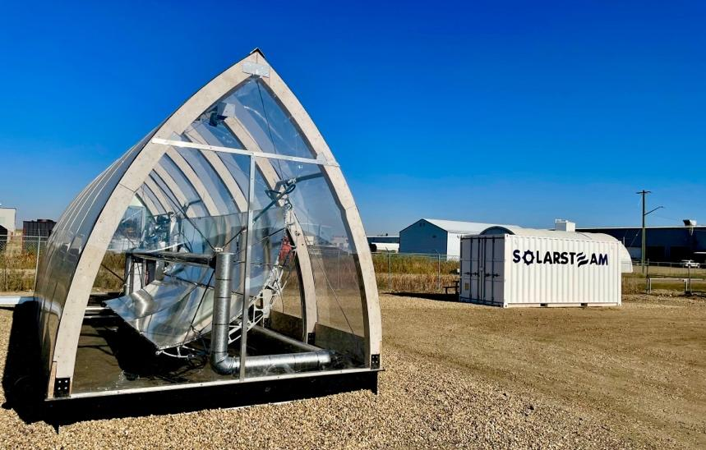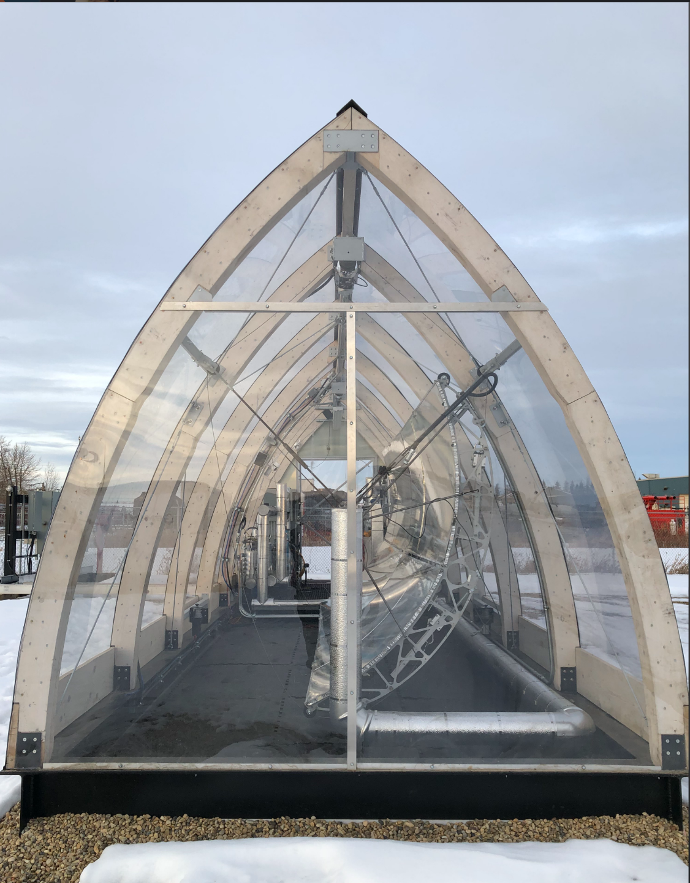

**Figure 1: Ponoka Pilot South-West View**

**Figure 2: Ponoka Pilot West View**

**Figure 3: SolarSteam / Base Element Energy 1.5 MWT System Process Flow Diagram**

SolarSteam’s purpose is to decarbonize some of the highest emitting and hardest to abate heavy industry segments. **The problem we address is the elephant in the energy room – industrial heat.** Globally, thermal energy requirements constitute close to 50% of total global GHG emissions. In Alberta approximately two thirds of GHG emissions come from the industrial sector. Since the industrial revolution, heat has been generated by burning fossil fuels. Our technology provides the same product - heat, without the problems of the current solution – supply, cost and emissions. Problem > [**VIDEO LINK**](https://www.youtube.com/watch?v=NIWfO97q2nw)

SolarSteam’s technology will be in competition with conventional heat generation technology, other solar thermal technology developers and novel decarbonization technologies that mitigate GHG emissions and offer financial savings to heat dependent industrial processes. SolarSteam’s direct solar thermal competitors are Heliogen, Absolicon, GlassPoint, Heliac, Skyven Technology, Heliovis, Synhelion and Allborg CSP. What differentiates SolarSteam is our novel enclosure which shelters the system from harsh weather conditions, while allowing the generating components to be lighter, more nimble and effective which lower CAPEX, while reducing maintenance (i.e. less dust connection) and downtime issues which lower OPEX.  All while providing high quality renewable heat and steam to a wide range of process heat requirements. The technology can accept a larger geographic range of extreme climatic conditions and temperatures enabling cross-sectoral deployment. Our modular nature has lower CAPEX and allows customers to add more capacity in time as their needs grow. The system can be integrated seamlessly into existing operations in a fashion that augments performance, reduces downtime and extends operations. OuAll our procurement processes, engineering, fabrication and manufacturing has been done in Alberta. These system/channels can be be used to advance local, national and international deployment. All of this allows us to service a market niche that is not addressed and inaccessible to our competitors.

**Top 3 novel features of SolarSteam’s are:**

* Transformative design of protective enclosure and ultra-light collectors for rapid deployment in Alberta climate conditions, enabling organizations to start with smaller scale projects at Phase 1 and 2 meeting 2030 without investing in stranded assets or amortizing already paid off CAPEX, and scaling capacity at Phase 3 to meet 2050 net-zero targets using step-change improvements;
* Modular deployment through strong focus on Design for Manufacturing, Shipping and Assembly principles (DFMSA) to reduce production costs and enable the most cost effective speed of deployment;
* Greenfield and brownfield plug & play integration with fully automated and remote operated controls and Thermal Energy Storage (TES) integration for consistent output and low O&M.

**SolarSteam currently has a field pilot constructed and commissioned for testing at a TRL 7 level** with a commercial partner in Ponoka, AB. Since its inception in 2017, SolarSteam has advanced the technology from market discovery, ideation and concept through multiple techno- economic assessments, prototypes, third party validation, and design, engineering, construction and commissioning of a demonstration TRL 7 pilot facility for field testing. Between 2020 and 2022, SolarSteam has engaged with a Calgary based EPFC (Scovan), TES developer (Sunamp) and leading research institutes such as the National Renewable Energy Laboratory (NREL) in the United States, University of Calgary, University of New Brunswick, Lambton College and Red Deer Polytechnic in Canada. This increased bench strength accelerated technology de-risking efforts, leading to the development of the field pilot deployment in Ponoka. The parabolic receiver and collector (RAC) system was designed and modeled using Autodesk software to create engineering drawings and provide a model for simulations. A preliminary analysis was conducted prior to pilot deployment for feasibility validation using solar thermal and ray-tracing calculations utilizing NREL’s software suite of the System Advisory Model (SAM) and Soltrace in which our enclosed system was modeled. Additional verification was performed in our custom-built spreadsheet based calculator which accounts for transmissivity and diffusion of the transparent membrane, shading from the enclosure structure, cosine effect of incoming light, reflectivity of the solar collector, geometry effects of the collector, transmittance of light through the glass envelope of the receiver and absorptivity of the solar receiver. Materials and vendors were selected to provide components for the pilot to test form, fit, and function in an operational environment. The field pilot finished construction and commissioning in Q2 of 2022. This pilot has 17 data points throughout the system allowing for the collection and analysis of variables including temperature, pressure, and flow rates, logging every 5 minutes with a daily backup. Data is being collected through a custom-built Programmable Logic Control system using automated sensors and instrumentation with a remotely accessible Human-Machine Interface allowing for 24/7 remote Supervisory Control and Data Acquisition.

**Figure 4: Ponoka Pilot Instrumentation Room 3D model**

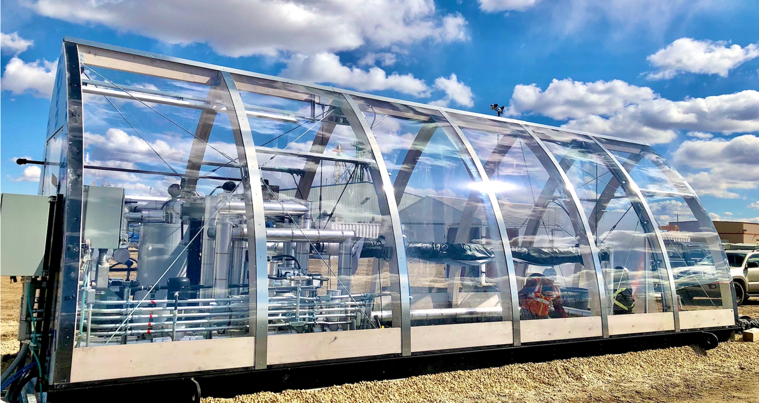

**Figure 5: Ponoka Pilot Instrumentation Room View**

In the past 26 weeks of operation our TRL7 field pilot has demonstrated: (1) Temperatures up to 102 degrees Celsius at a flow rate of 60 L/h showing a Delta T of 30 degrees Celsius between the inlet and outlet of the solar receiver; (2) Hybrid Integration with secondary source of heat; (3) Successful shutdown and startup at -30C; (4) Withstanding 117km/h wind and golf size ball hail; (5) Phase Change Material (PCM) based Thermal Energy Storage (TES) integration; (6) Delta T of 50 at low flow across the receiver, (7) Remote automated controls, and (8) Winter operation using boiler feed water with 4 levels of shut- down contingencies.

SolarSteam’s successful pilot demonstration in Ponoka was completed with the support of a Calgary based EPFC, manufacturer/fabricator, national and international research groups and SolarSteam’s in-house expertise. The collective expertise within this partnership, along with a focus on building a robust system that represented the potential for deployment in a wide range of industrial applications, meant that the additional challenges left to be resolved will be addressed with the next few demonstration projects before we can roll out mass production and large scale deployment. **ERA’s investment in this project will enable SolarSteam to addresses the following technological de-risking and advancements:**

* Objective 1: Validating the front end engineering and design associated with a specific deployment.
* Objective 2: Validation of system integration into real-life setting.
* Objective 3: Validation of system interoperability and modular configuration with other complimentary technology to ensure existing processes and systems operate to optimal efficiency.
* Objective 4: Validation of Alberta focused Design for Manufacturing, Shipping and Assembly (DFMSA) using Alberta procurement, manufacturing, fabrication, and shipping supply chain.
* Objective 5: Supply chain, Scale-up, logistics, and deployment. Securing material and components supply chain through covering tooling costs, bulk material orders, fabricator/manufacturer agreements and contracts, and preferred shipper contracts and rates.
* Objective 6: Validation of data management and integrated control systems.

Ultimately, the project will support deployment of advancing SolarSteam + TES integration novel technology to full-scale cross-sectoral commercialization technology, moving the solution from a TRL 7 to a TRL 9, using Alberta-wide supply chain and workforce sources for expertise in research, design, engineering, procurement, fabrication/manufacturing and O&M.

1. **Project Implementation Plan**

**Base Element Energy’s Oil Emulsion treatment facility with D58 status in Cynthia, AB is the commercial site selected for the proposed project.**

Project Objectives: TRL 9 Flagship project, Alberta heavy industry market acceptance, proven operational viability, validated step-change GHG offset potential, 10 new Highly Quality Personnel (HQPs) created, improve market access and full readiness for large-scale commercialization.

Project Work Scope: Using Front End Loading and Phase-Gate approach SolarSteam and partners will start with overall project Front End Engineering and Design (FEED) up to approval for construction and stage the procurement, fabrication, construction and commissioning in 3 phases: Phase 1 – 250kWt, Phase 2 – 750kWt, Phase 3 - 1.5MWt.

Project Deliverable: Deployment of a 1.5MWt SolarSteam system integrated with a Sunamp CentralBank 20 PCM based TES unit at Base Element Energy facility in Cynthia, Alberta by the end of 2025 delivering 10,000 GJ of renewable heat and displacing 630 tonnes of CO2 per year.

This will be a first of a kind deployment of SolarSteam technology paired with TES at this scale with a commercial partner with strong operational and facility plans to achieve net-zero deploying SolarSteam and other complimentary technology (LoS attached). This project aims to successfully demonstrate SolarSteam’s technology with a 1.5 MWt system deployment integrated with Base Element Energy’s existing 68,000 square metre petrochemical wastewater treatment facility. The 1.5 MWt solar field will consist of 3 rows of 10 solar modules per row providing heat to the host facility via a integrated heat exchanger and 1.8 MWh TES unit. The overall objective is to assess and validate SolarSteam technology in an operational environment to assess system performance and thermal energy output provided for industrial process heat. This 1.5 MWt deployment will demonstrate the fully commercial (TRL 9) system readiness with modular design, manufacturing, shipping to site, assembly, commissioning and operations. The modular design of the units deployed as part of this project will serve as the template for large scale manufacturing. The Front End Loading approach to FEED and Phase-Gate approach to construction and commissioning will become the project execution style for future deployments.

Locations of Key Project Activities: Design and Engineering – Calgary. Project Management – Calgary. Manufacturing & Fabrication – Calgary, Red Deer, Ponoka, Edmonton. Project host site – Cynthia, AB.

**Project Roadmap and Milestones:**

* FEED for the entire 1.5MWt + TES system – 8 months / $700k
* Project management for entire project + overhead – 24 months / 800k
* Phase 1 (250kWt + TES) land, procurement, construction and commissioning – 12 month / $750k
* Phase 2 (500kWt + TES) land, procurement, construction and commissioning – 18 month / $1M
* Phase 3 (750kWt + TES) land, procurement, construction and commissioning – 24 month / $1.5M
* 1 full year of operations, management and testing of entire 1,5MWt system – 36 months / 250k

Total Budget: $5M Timeline: 36 months

**Organizations involved in the project consortium:**

* SolarSteam – lead technology developer and lead project manager (confirmed)
* Scout Energy / Sunamp – Thermal Energy Storage technology developer (confirmed)
* Base Element Energy – project host (confirmed)
* Scovan – Engineering, Procurement, and Construction partner (confirmed)
* JRV Oilfield, Red Deer Polytechnic, Gemini Fabrication, Exergy – Fabrication partners (confirmed)
* BP Canada Energy Group ULC – Finance & Energy as a Service partner (in-discussion)
* University of Calgary – Capacity Building and Knowledge Transfer partner (confirmed)

**Core team members:**

* Apostol Radev, CEO / SolarSteam – BBA, MSc with 15 years in Operations Management
* Robert Garth, CTO / SolarSteam – P.Tech.(Eng.), BSc, BA with 15 years in Mechanical Design
* Jeff Reading, CDO / SolarSteam – MA, BA with 30 years in Development and Commercialization
* Dustin Deveau, CEO / Base Element Energy – BBA with 15 years in Logistics, Finance and Energy
* Brent Wylie, President / Scout Energy – BA with 30 years in Project Management in construction
* William Edrich, Director of BD / Sunamp – BSc with 25 years in Energy and Commercial Structures
* Kevin Westergaard, Structurer/ BP Canada Energy Group – BCom with 15 years in Energy Trading
* Aggrey Mwesigye, Assistant Professor / UCalgary – PhD, P.Eng., MSc with 10 years in Solar Thermal
* Donovan Nielson, CEO / Scovan – P.Eng. with 20 years in Oil & Gas and Heavy Industry EPC
* Jeff Vrolson, President / JR Fabrication – Red Seal Welder with 15 years in Welding and Fabrication

The partners contribution of funds have been secured on milestone/phase-gate completion roadmap. The support from ERA will help get our technology to market faster, accelerate GHG displacement and provide job-creation and economic diversification benefits. ERA’s contribution to this project will help with positioning Alberta’s industry for success in the future global economy. The project partners will provide $4M in cash and in-kind contributions with the remaining $2M as part of this request with ERA.

SolarSteam has strong existing relationships with all project partners at C-suite level enabling quick internal approvals and a track record of executing a previous project successfully with the field pilot in Ponoka. We also have experience executing participation agreements at Provincial and Federal level and a proven record of engagement with various research, labs and academic institutes on capacity building and knowledge transfer studies and workshops. SolarSteam’s industrial partnerships and robust demonstration pilot process identified and addressed certifications, licences, and code compliance requirements to proceed in an operational setting.

|  |  |  |  |
| --- | --- | --- | --- |
| **Risk and Mitigation Strategy** | | | |
| Type of Risk | Level of Risk | Impact | Mitigation Strategy |
| System Performance | Low | High | System performance has already been validated through Ponoka pilot. |
| Integration | Medium | High | The system can utilize boiler feed water or heat transfer fluid for seamless integration. |
| Thermal Energy Storage (TES) | Low | Medium | TES integration is currently being demonstrated with Ponoka pilot. |
| Automation and Controls | Low | Medium | The system will be designed as automated operation with remote access and controls. |
| Enclosure Design | Low | Low | Enclosure design and materials have been specifically selected for Alberta conditions. |

This proposed project intends to define, address and fully understand the underlying risks and barriers with engineering issues, research problems and technical complexities related to local manufacturing/fabrication, integration, interoperability, heat production and GHGs reduction performance, and visibility of SolarSteam technology within the industrial sector in Alberta.

ERA's funding of $2M for this project will allow SolarSteam to accelerate our Alberta-made focused Design for Manufacturing, Shipping and Assembly program and will provide more accurate validation on design and material selection. This project will benefit industry by demonstrating SolarSteam's ability to address a greater number of technical uncertainties related to speed to market and scalability which will lead to shortening the commercialization timelines for larger projects.

|  |  |  |
| --- | --- | --- |
| FINANCIAL CONTRIBUTORS | AMOUNT | STATUS |
| ERA (Requested) | $2,500,000 | Applied for |
| SolarSteam | $1,000,000 | Committed |
| Base Element Energy | $1,000,000 | Committed |
| Scout Energy / Sunamp | $300,000 | Committed |
| Scovan | $300,000 | In discussion |
| IRAP | $100,000 | Committed |
| BP Canada Energy Group | $400,000 | In discussion |
| Total Financing | $5,600,000 | |

1. **GHG and Non-GHG Benefits**

The primary environmental benefit from implementing SolarSteam + TES systems is displacing the CO2 produced by burning fossil fuels for heat generation in industrial processes.

Our systems have the potential to provide reductions in particulate emissions by displacing diesel and coal as fuel for boiler systems. Given that natural gas is the primary fuel used in conventional boilers across Alberta, detailed particulate emissions calculations have not been carried out at this stage.

The proposed 1.5 MWt facility is projected to save approximately 12,343 GJ of natural gas per year resulting in an annual emissions reduction of over 663 tonnes of CO2. With a project lifespan of 25 years this project will save ~310,000 GJ of natural gas and provide CO2 reduction of ~16,575 tonnes.

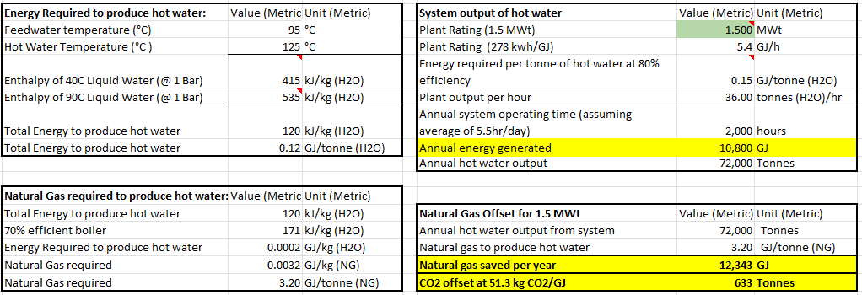

The following assumptions are made: (1) DNI is 1.5 MWh/m2/year at Red Deer (AB); (2) The plant produces heat for 2,000 hours per year; (3). Natural Gas energy density is 53.6 MJ/kg or 0.0536 GJ/kg (Source IGU Natural Gas Conversion Guide); (4) 1kg CH4 x (44 g CO2/16 g CH4) produces 2.75kg of CO2; thus 2.75 kg of CO2/0.0536 GJ/kg of NG produces 51.3 kg CO2/GJ; (5) Heat data taken from tlv.com.

With a Total Obtainable Market of $2.5 Billion by 2030 and $36.5 billion by 2050 (see answer to question 4.3 for detailed breakdown of market penetration rate assumptions) we forecast the potential to:

* deploy 1.3 GWt by 2030 reaching 574,000 annual and 1,768,000 cumulative tonnes of CO2 offset
* deploy 15 GWt by 2050 reaching 12,000,000 annual and 142,000,000 cumulative tonnes of CO2 offset

The portion of GHG benefits expected within Alberta represent 20% of the above forecasts.

Given that two thirds of emissions in Alberta comes from industrial processes SolarSteam provides a step-change emissions benefits across Alberta’s industrial sector to secure the competitiveness of existing and new industries in an increasingly emissions- constrained future addressing 2030 and 2050 targets. SolarSteam offers clients the ability to start with a demonstration project at Phase 1 deployment that validates integration, heat production and Thermal Energy Storage (TES). Ultimately Phase 1 introduces a hybrid heat solution and TES as a flagship project on the path for decarbonizing hard to abate industrial processes. At Phase 2 deployment, we can scale up the demonstration project to a larger system and validate measurable GHG displacement of anywhere between 20% and 40%. The way that displacement will be achieved is by supplying renewable heat to already existing thermal energy generation systems. SolarSteam’s system will generate process heat during the day while also charging TES, and discharge the renewable heat stored in TES at night as well as provide a buffer to system generation intermittency to stabilise output during the day. This could help meet 2030 targets set by Canada’s Emissions Reduction Plan(s) without amortizing paid off asset base of legacy capital investments or investing in a technology that can become a stranded asset. At Phase 3 we provide companies with a clear path to net zero through the addition of a multi-megawatt SolarSteam and TES system paired with a complimentary source of green heat (geothermal, biomass, green H2) as a back-up.

This transformative industrial technology will help to reach 2030 and 2050 net-zero targets and can unlock significant first-mover advantages for Alberta’s existing and emerging economic sectors while also contributing to improved competitiveness and resilience. Other, non-GHG environmental benefits associated with the technology include productivity and performance gains, improved product quality,better land use to energy ratio compared to PV, storm water collection and treatment capabilities, producer water treatment applicability and system deployment over remediated oil & gas assets.

SolarSteam technology will not only enhance heavy and small industry production with solar energy across multiple sectors, but it will also reduce costs, carbon emissions and create jobs along the supply chain of clean energy innovation, engineering, legal, accounting, manufacturing, construction, operations and training of operators. The economic benefits of the system can establish Alberta heavy industry as the next big market for solar in Canada and attract Angel and Venture Capital investments into other clean-tech projects and help Alberta finance the transition to a low-carbon economy. Projected revenues of 6.5 billion CAD generated from 10% of renewable heat projects adoption in local heavy industry could help Alberta finance the transition to a low-carbon economy.

The opportunity to profile Alberta innovation, commitment to decarbonization and demonstrate the exporting of Canadian technologies is significant. This demonstration project will create the conditions for SolarSteam, and commercialization collaborators, to capture market validated performance data for leveraging across industrial sectors, strengthen ESG commitments, and develop opportunities for future renewable energy and heavy industry modernization projects.

This project will increase the capacity of SolarSteam’s team, and partners, to accelerate project timelines with the addition 4-6 full time HQP over the next 3 years, retention of 3 interns, addition of 2 interns year in the next 3 years and support 5-8 contractors over the lifetime of the project.

These are challenges that exist with all deployments and we are confident we have the capacity and expertise to mitigate these issues. Life Cycle Assessment (LCA) will be developed on a case to case basis depending on our clients specific needs to address cradle to cradle and/or product end of life disposal.

This project will provide a platform for further strengthening and complementing SolarSteam’s involvement with post-secondary/research institutions conducting socio-economic and techno-economic feasibility studies and capacity building and knowledge share transfers programs on renewable heat research and development and commercialization. SolarSteam has onboarded and mentored 15+ interns in the last 3 years and has supported 10+ students with capstone projects.

1. **Market and Value Proposition**

Over the last 3 years SolarSteam has been collaborating with a multi-billion-dollar petrochemical company with significant operations in Alberta. This company has provided in-kind and financial support with respect to validation of the design of the technology and has papered its intent to evaluate results of SolarSteam’s first commercial facility with the intention of becoming an early beachhead market adopter. Other prospect clients in Alberta that SolarSteam is collaborating with include sustainable food production, mining, water and waste treatment, bio-fuels production, geothermal and district heating.

Large Final Emitters (LFEs) are the primary market in Alberta. SolarSteam has developed a [Market Assessment](https://solarsteam.docsend.com/view/gbsn5pjjys7ghtmk) based on the Large Final Emitters (LFEs) database for Southern Alberta.

As shown by the linked [Market Assessment](https://solarsteam.docsend.com/view/gbsn5pjjys7ghtmk), SolarSteam assessed 421 operations and identified 224 facilities with a market assessment rating of 60% or greater, for a total estimated thermal need of 5,208 MW with a potential CO2 offset of 9,214,000 metric tonnes per year and overall market potential in Southern Alberta and Saskatchewan of $13 Billion. 70% of the identified facilities are in Alberta.

Unlike other clean technologies, which are often highly sector-focused, the cross-sectoral deployment versatility of SolarSteam enables deployment in multiple industry verticals and geographical regions. Based on various internal and external market assessments, by 2030, SolarSteam has identified a Total Addressable Market (TAM) of $1.15 Trillion > Serviceable Addressable Market (SAM) of $200 Billion (~17% of TAM) > Serviceable Obtainable Market (SOM) of $2.5 Billion (~0.0125 % of SAM) focusing on markets in Canada, the US, Europe, and certain parts of MENA with sufficient land available for deployment for below 400C (low/med temperatures). An emissions reduction potential report through CRANE developed by climate investment fund VertueLab, validated SolarSteam’s forecasted, TAM, SAM and SOM and provides insight into market potential by 2050 of $6T TAM, $1T SAM and $36.5B SOM.

Solar Heat for Industrial Processes (SHIP), describes SolarSteam’s technology ideal market segment. The SHIP segment fulfills a substantial amount of heat demand in industrial processes within any given country, regardless of the geographical location. In economies with strong heavy industry segments, SHIP technology can provide technically about half of this energy consumption by supplying hot water and steam to thermal energy-dependent processes in a temperature range of up to 400°C. Some of these markets include Petrochemicals, Mining, Upstream and Downstream Conventional and In-Situ Oil & Gas, Pulp & Paper, Food Processing, Health Care and Materials Transformation.

Forecasted SolarSteam Levelized Cost of Heat (LCOH) is between $35/MWh and $60/MWh depending on scale and deployment location. LCOH is based on a 25 year lifespan and includes CAPEX + OPEX. A 25MWt SolarSteam + TES system would have an average capital cost of $30M with operating cost of 350k per year. Such system would be able to produce 180,000 GJ of energy, displacing 10,550 tonnes of CO2 per year. Based on forecasted cost of fuels ($15/GJ) and CO2 ($170/tonner) in Alberta the projected ROI for this system would be between 6-7 years. Both CAPEX + OPEX on a 100MWt+ system would come down by 25% resulting in a forecasted ROI of 4-5 years and $25/GJ price would result in ROI of 3 years.

SolarSteam’s Alberta-made focused Design for Manufacturing, Shipping and Assembly (DFMSA) will allow for 80% locally build system using Alberta and Canadian procurement, manufacturing, fabrication, and shipping supply chain. This project will serve as a flagship phase-gate deployment to demonstrate step change approach to meet 2030 and 2050 target and will allow SolarSteam to lay out the foundation for speed to market and scalability by establishing local FEED to commissioning and O&M supply chain.

Expediting mechanical and electrical components regulatory approval will address some of the concerns early adopters have with integrating novel technology. One of the benefits that came out of the Medicine Hat CSP project is that the Alberta Boiler and Safety Authority (ABSA) has developed policies to accommodate the deployment of concentrated solar systems. Incremental improvements using existing technologies cannot deliver sufficient progress on their own, while potential step-change solutions face significant challenges in securing capital investment and market acceptance. ERA’s support for this project will address capital and market acceptance challenges and will demonstrate how novel technology can integrate with existing assets right here in our province, instead of forcing technology developers to seek early adopters and beachhead markets elsewhere.

We plan to follow ERA’s distribution and sharing of results guidelines and work with our local network of commercialization collaborators to engage in workshops, research papers, presentations and spin-off IP.